SFRA Mollie LINK Integration

*Version 20.1.0*



Table of Contents

1. Summary 4

2. Component Overview 5

Functional Overview 5

Use Cases 6

Limitations, Constraints 6

Compatibility 6

Privacy, Payment 6

3. Implementation Guide 7

Setup of Business Manager 7

Setup Storefront Cartridges 7

Setup Business Manager Cartridges 8

Import data 9

Configuration 10

Configure Site Preferences 10

Configure Services 11

Configure Payment Methods 12

4. Testing 13

Checkout 14

Checkout as a guest 14

Checkout as an authenticated customer with a new card 16

Checkout as an authenticated customer with an existing card 18

5. Operations, Maintenance 20

Data Storage 20

Availability 21

Support 21

6. User Guide 22

Roles, Responsibilities 22

Business Manager 22

Customer Service Center actions 22

Performing a payment cancel 22

Performing a payment refund 24

Performing a order shipment 25

Request payment link 25

Jobs 27

7. Known Issues 28

8. Release History 28

# Summary

This LINK cartridge is the official Mollie Commerce Cloud LINK integration.

You can find more information about Mollie here: <https://www.mollie.com/>. It is required to create an account and fill in the required settings before going live. There is always an option to create a free test account here: <https://www.mollie.com/dashboard/signup?lang=en>.

More information to get started: <https://www.mollie.com/be/developers>.

More information about the JSON API: <https://docs.mollie.com/reference/v2/payments-api/create-payment>.

More information about general integration: <https://github.com/mollie> This is handy to get a general idea of what Mollie is capable of.

The LINK cartridge was build and tested with SFRA version 5.0.1 and B2C Commerce version 20.9 (Compatibility Mode: 19.1)

# Component Overview

## Functional Overview

Mollie provides an easy way to integrate with a wide range of payment methods and wallets. The integration makes use of REST API calls to Mollie. Commerce Cloud will then handle the responses and will process orders.

It is also possible to handle payment cancels, refunds and shipments in the Commerce Cloud Customer Service Center.

The following payment methods are supported by default:

* Bancontact
* Credit card
* PayPal
* iDeal
* Sofort Banking
* Bank transfer
* Belfius
* KBC
* Pay later
* Slice it
* Gift cards
* ING Home'Pay
* Giropay
* Eps
* Przelewy24

The following wallets are supported by default:

* Apple Pay

## Use Cases

* As a customer, complete a checkout processes using the Mollie payment methods with the ability to remember your card data when logged in.
* As the merchant, view the Mollie payment details in the Business Manager
* As the merchant, perform custom actions regarding the payment (cancel payment, refund payment, ship order)
* As the merchant, configure multiple settings in the custom site preferences

## Limitations, Constraints

The plugin was build to work on the SFRA demo site.

The following Mollie API’s are (partially) supported:

* Payment API
* Methods API
* Refunds API
* Orders API
* Shipment API
* Customers API

## Compatibility

Sitegenesis: Not supported

SFRA version: 5.0.1

Compatibility mode: 19.1

## Privacy, Payment

Credit card data is never processed on the Commerce Cloud side.

New payments will be entered and processed on the Mollie Payment Page.

There is also a possibility to use the Customers API. This feature will allow the customer to remember and reuse the card data entered at a later stage. Card data is always stored on the Mollie environment, never in Commerce Cloud.

# Implementation Guide

The LINK integration was developed using Visual Studio Code together with the prophet plugin.

Open the project follow the steps:

* Make sure that node and npm are installed
* Go to the project root and enter “npm install” in the terminal
* After the install is complete, enter “npm run compile” to compile the css and js
* Upload the cartridges to the Business Manager

## Setup of Business Manager

### Setup Storefront Cartridges

The first thing to do is to setup the Storefront cartridges. The plugin exists out of 3 storefront cartridges. These cartridges will need to be added to Cartridge Path of the required Storefront Site(s).

|  |  |
| --- | --- |
| Name | Purpose |
| int_mollie | Contains all the business logic pertaining order and payment management through the Mollie API. |
| int_mollie_sfra | Contains Payment and Checkout controllers and templates. |
| mollie_sfra_changes | Contains overwritten SFRA controllers and templates |

It is important to add the cartridges in the following order. Insert these cartridges *before* **app_storefront_base**cartridge.

|  |
| --- |
| Cartridge List |
| mollie_sfra_changes:int_mollie_sfra:int_mollie |

### Setup Business Manager Cartridges

When this is done, it is time to setup the Business Manager cartridges. There are 2 cartridges that you will need to be added to the cartridge path for the Business Manager.

|  |  |
| --- | --- |
| Name | Purpose |
| int_mollie | Contains all the business logic pertaining order and payment management through the Mollie API. |
| bm_mollie | * Contains a job to check for orders that have not been completed after 24 hours (configurable) and fails them.  If by any chance the payment flow was completed for this order but failed, the order will be set to the complete status. * Contains custom Customer Service Centre actions per order. These actions will help maintaining the order. |
| app_storefront_base | Add this cartridge to provide the necessary business logic to the custom actions in the Customer Service Center |

It is important to add the cartridges in the following order.

|  |
| --- |
| Cartridge List |
| bm _mollie:int_mollie |

### Import data

The project also contains a **data** folder. This data folder contains jobs, custom attributes, services, payment processors and payment method required.

To import the data, follow the next steps:

* Site import
  1. Go to **Administration à Operations à Site Import & Export**
  2. Under **Import & Export Files** click on **Upload**
  3. Upload the **mollie-site-export.zip**
  4. Import the uploaded file

## Configuration

### Configure Site Preferences

After importing the data, the custom site preferences become available.

These are all the custom site preferences that all configurable. Make sure to create an API user in the Mollie backoffice.

1. Go to **Merchant Tools** à **Site Preferences** à **Custom Preferences**
2. If the custom attributes where imported, you should see an attribute group named **Mollie Config**
3. Click on the group and you should see the settings listed below

|  |  |  |
| --- | --- | --- |
| ID | Type | Description |
| mollieEnabledMode | Set of Strings | Environment used (TEST/LIVE). In TEST mode “mollieBearerTestToken” will be used, in LIVE mode “mollieBearerToken” will be used. |
| mollieBearerToken | String | This API Key will be used when “mollieEnabledMode” is set to TEST. You can find your API key in your Mollie Profile, it starts with live. <https://www.mollie.com/dashboard/org_9306261/developers/api-keys> |
| mollieBearerTestToken | String | This API Key will be used when “mollieEnabledMode” is set to LIVE. You can find your API key in your Mollie Profile, it starts with test. <https://www.mollie.com/dashboard/org_9306261/developers/api-keys> |
| mollieBearerToken | String | You can find your Profile ID in your Mollie Profile: <https://www.mollie.com/dashboard/org_9306261/developers/api-keys> |
| mollieDefaultEnabledTransactionAPI | Set of Strings | The default enabled method API (ORDER/PAYMENT). Read more about the differences between the Payment and Orders API: <https://docs.mollie.com/orders/why-use-orders> |
| mollieDefaultOrderExpiryDays | Set of Integers | Default expiry days for orders created with the ORDERS API. |
| mollieEnableSingleClickPayments | Boolean | Indicates if Single Click Payments are enabled. Read more about Single Click Payments and how it improves your conversion. <https://help.mollie.com/hc/en-us/articles/115000671249-What-are-single-click-payments-and-how-does-it-work-> |
| mollieComponentsEnabled | Boolean | Indicates if Mollie Components are enabled. Read more about Mollie Components and how it improves your conversion. <https://www.mollie.com/en/news/post/better-checkout-flows-with-mollie-components> |
| mollieLogCategory | String | Log category used by SFCC. The log category can be selected under: "Administration -> Operations -> Custom Log Settings". |

### Configure Services

It is necessary to configure the correct Mollie service credentials.

1. Go to **Administration à Operations à Services**
2. If the import was successful, you should see the following services  
   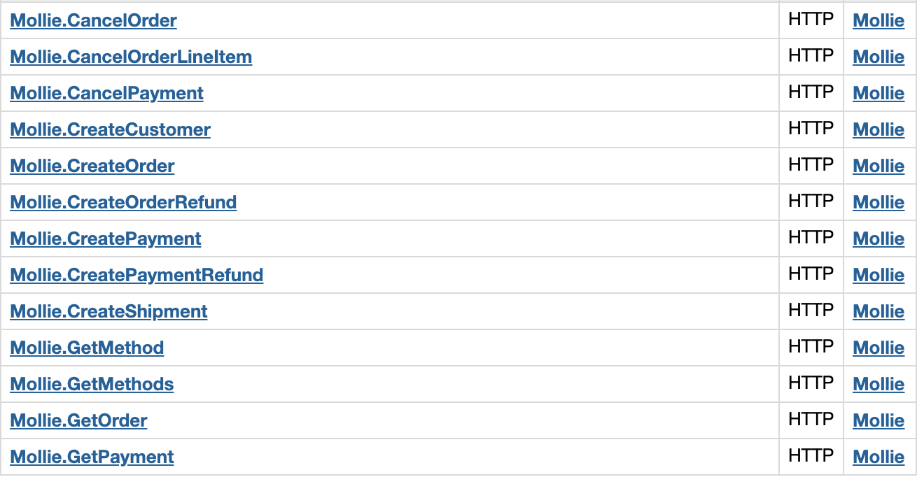
3. Go to the **Mollie Credentials**
4. Fill in the correct URL

### Configure Payment Methods

Validate that the payments methods where imported correctly.

1. Go to **Merchant Tools à Ordering à Payment Methods**
2. There should be a list that contains the following payment methods  
   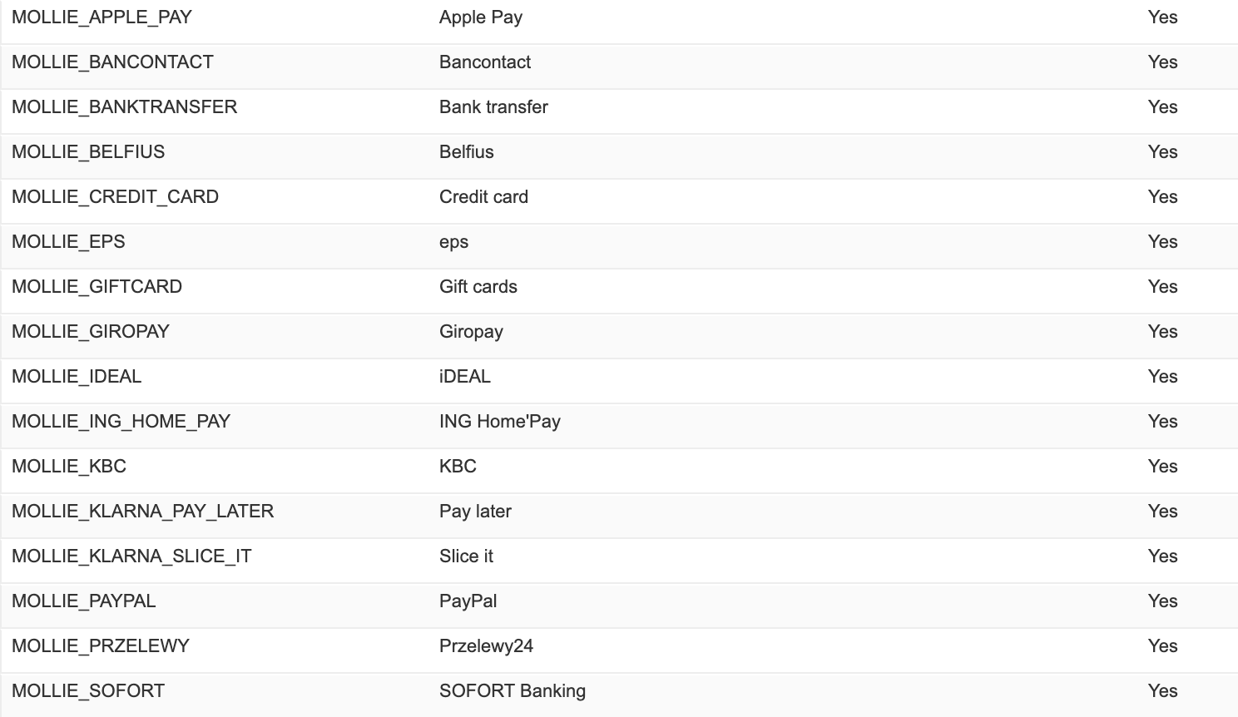
3. These payment methods should be linked to the **MOLLIE_ECOM_DEFAULT** payment processor, if the payment method uses Mollie components use **MOLLIE_ECOM_CREDIT** instead.

It is possible to change the **Name** and **Image** of the **Payment Methods.**

There are also some custom attributes available on the payment methods.

|  |  |  |
| --- | --- | --- |
| ID | Type | Description |
| molliePaymentMethodId | String | The payment id from Mollie |
| mollieOrderExpiryDays | Enum-of-strings | expiry days for orders created with the ORDERS API. |
| mollieEnabledTransactionAPI | Enum-of-strings | enabled method API (ORDER/PAYMENT). Read more about the differences between the Payment and Orders API: <https://docs.mollie.com/orders/why-use-orders> |

# Testing

Configure the backend accordingly. Make sure the following Site Preferences are configured according to your Mollie account:

1. mollieEnabledMode
   * Set to “TEST” when testing with a Mollie test API key, “LIVE” for a production API key
2. mollieBearerToken
   * The token found on your Mollie dashboard
3. mollieBearerTestToken
   * The test token found on your Mollie dashboard
4. mollieDefaultEnabledTransactionAPI
   * The default enabled method API (order/payment)
5. mollieDefaultOrderExpiryDays
   * The default expiry days for orders created with the orders API
6. mollieEnableSingleClickPayments
   * Set to true when you want to enable Single Click payments
7. mollieComponentsEnabled
   * Set to true when you want to enable Mollie Components

## Checkout

### Checkout as a guest

1. Add a product to your cart
2. Continue to payment step
3. Select a payment method and click on “Next: Place Order”

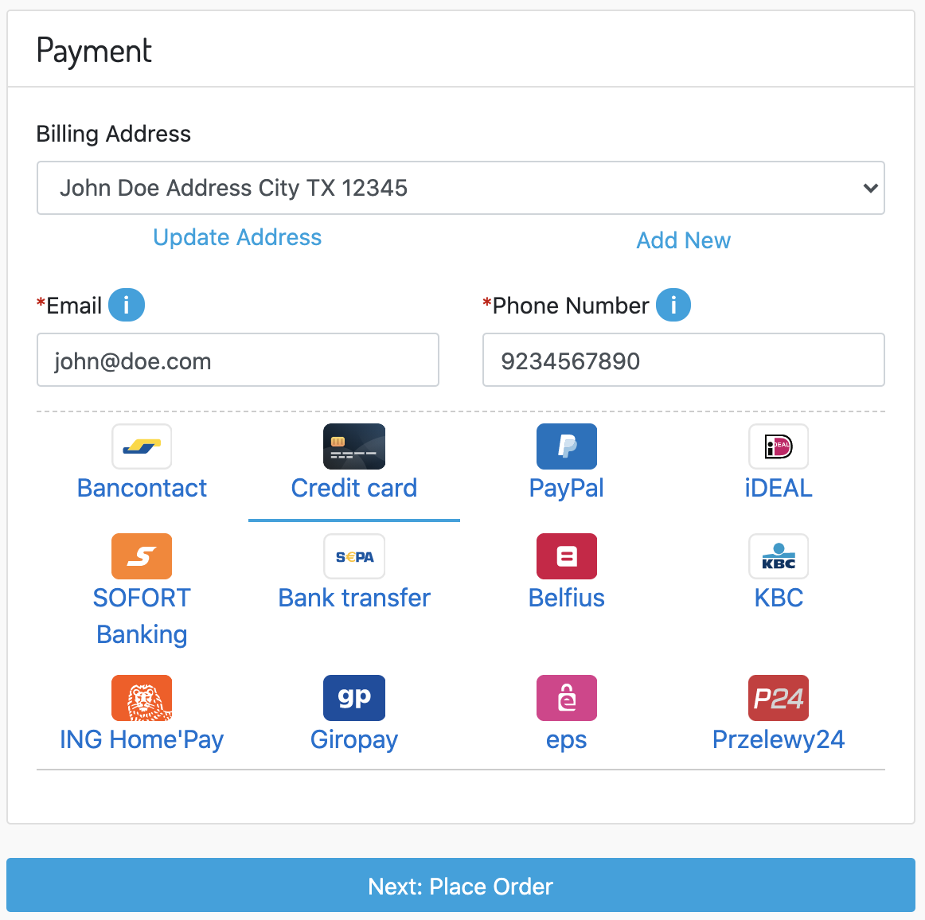

1. Validate the order and click on “Place Order”  
   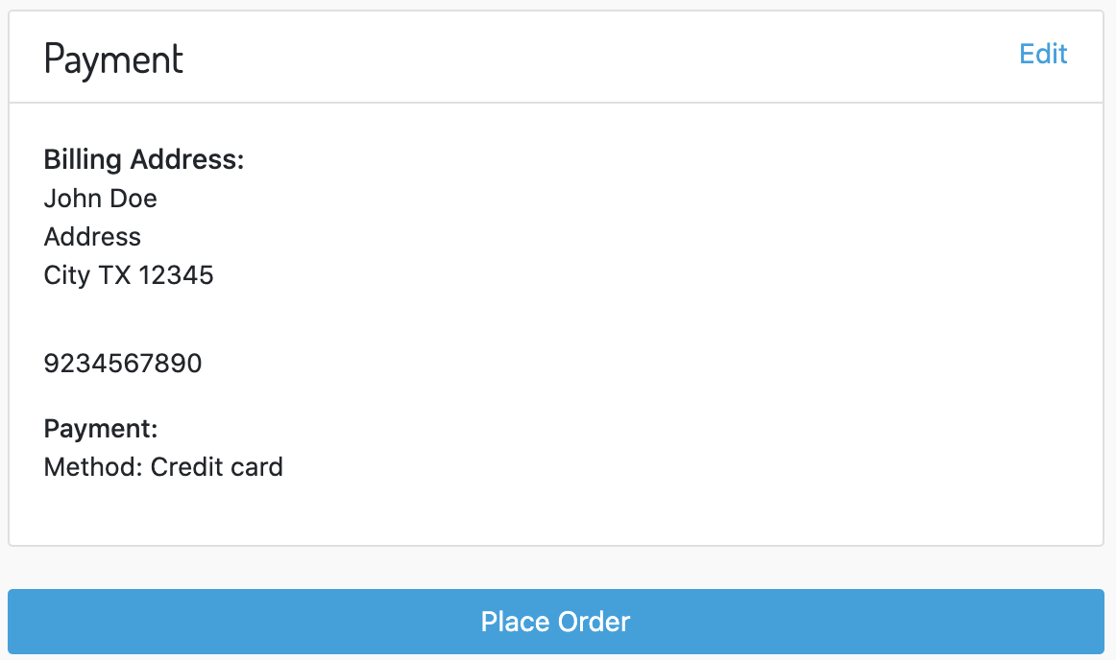
2. The checkout will now redirect to Mollie  
   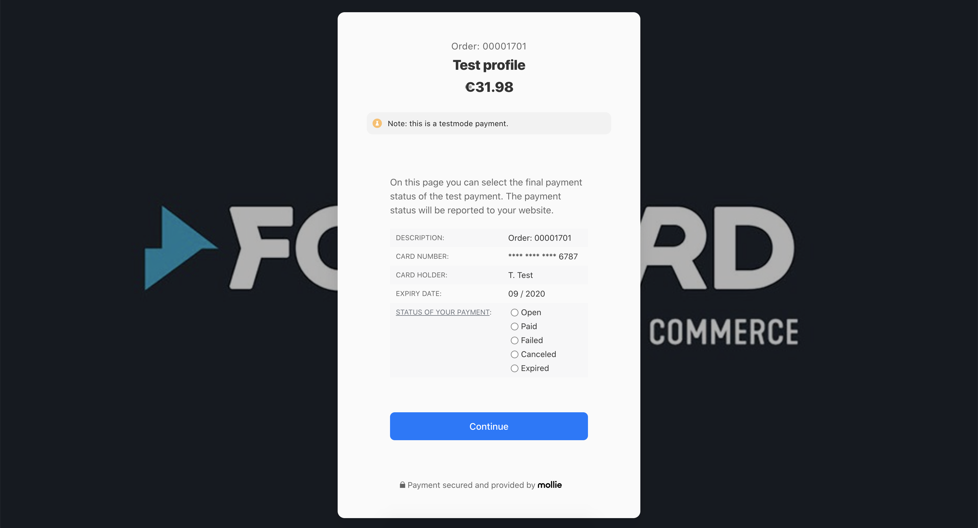
3. Fill the details and continue the payment.
4. Now an order is created in the Business Manager.   
   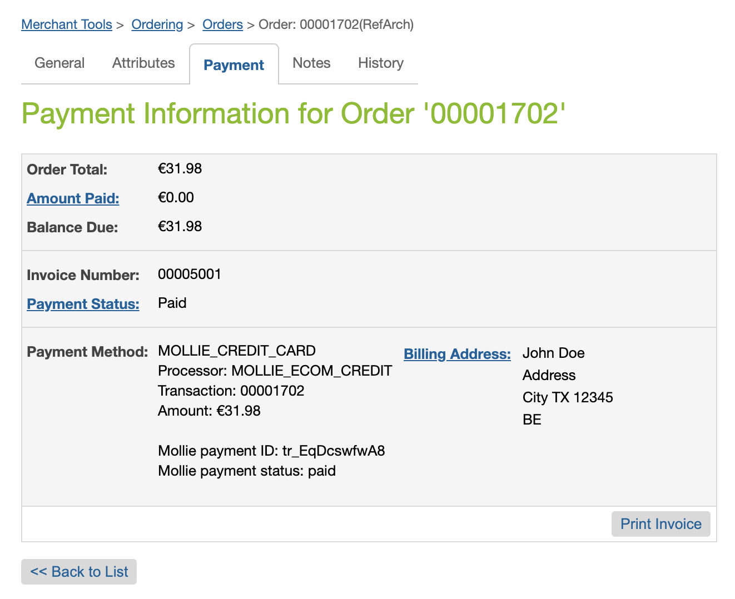

### Checkout as an authenticated customer with a new card

1. Add a product to your cart
2. Continue to payment step
3. Select a payment method. If the mollieEnableComponents and mollieEnableSingleClickPayments settings are enabled, the option to save a card for later use will become visible.  
   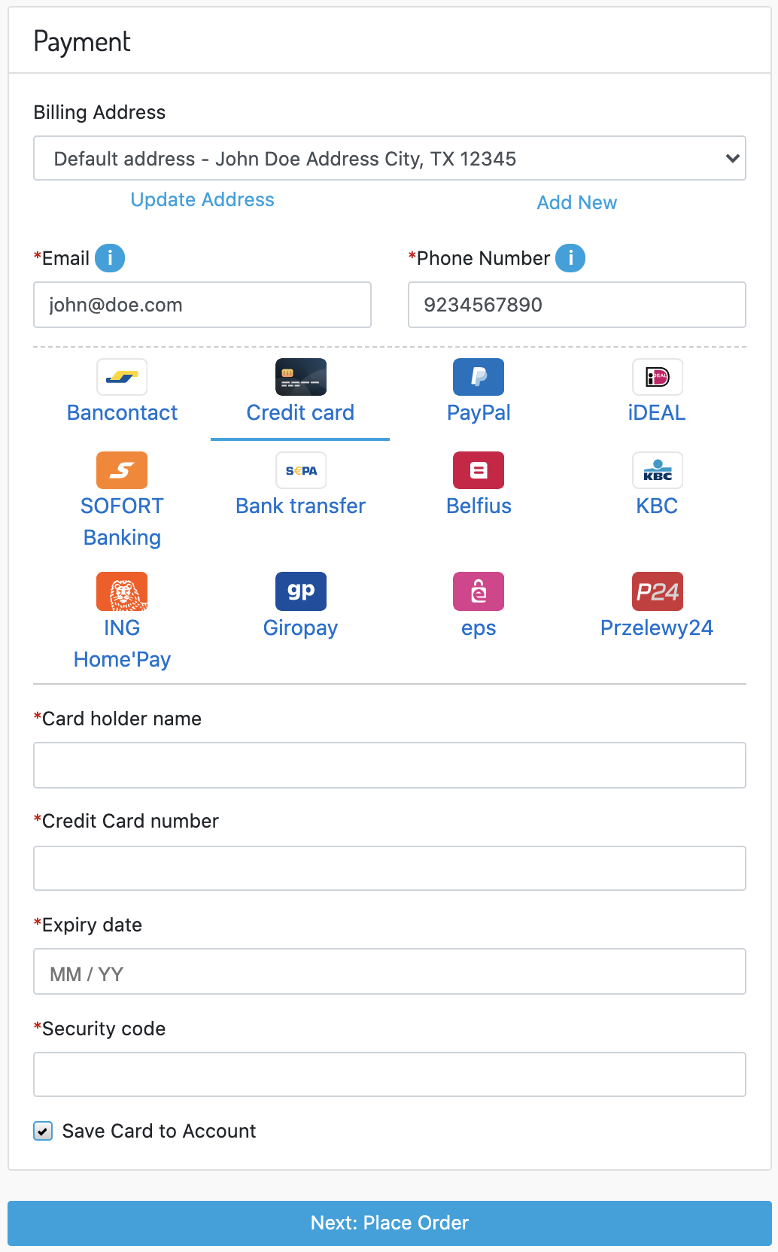
4. Enable the “Save card to Account” option
5. click on “Next: Place Order”
6. Validate the order and click on “Place Order”  
   
7. The checkout will now redirect to Mollie  
   

### Checkout as an authenticated customer with an existing card

1. Add a product to your cart
2. Continue to payment step
3. Select a payment method. If the mollieEnableComponents and mollieEnableSingleClickPayments settings are enabled u can pick your card in the Mollie checkout.  
   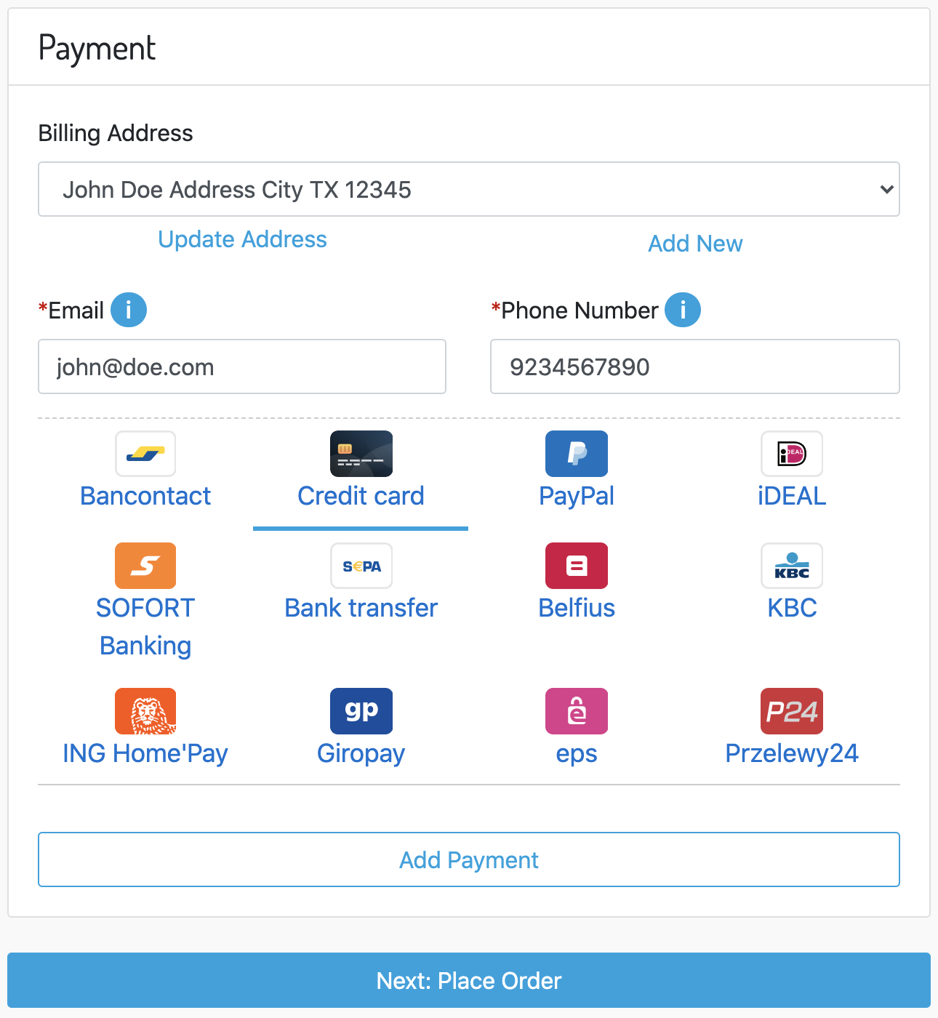
4. click on “Next: Place Order”
5. Validate the order and click on “Place Order”  
   
6. The checkout will now redirect to Mollie and you can pick an existing card used on a previous order.

# Operations, Maintenance

## Data Storage

Data is stored on multiple locations.

* System Objects
  + PaymentMethod
    - molliePaymentMethodId – The id of the Mollie payment method
    - mollieOrderExpiryDays – The expiry days for orders created with the order API
    - mollieEnabledTransactionAPI – The enabled method API for this payment method
  + PaymentTransaction
    - molliePaymentId –The id of the Mollie payment for orders created with the payment API
    - molliePaymentStatus – The status of the Mollie payment for orders created with the payment API
    - mollieIssuerData – Selected issuer data
  + Order
    - mollieOrderId – The id of the Mollie order for orders created with the order API
    - mollieOrderStatus – The status of the Mollie order for orders created with the order API
    - mollieUsedTransactionAPI – The Mollie method API used for creating the transaction (order/payment)
    - mollieRefundStatus – Contains the status of the refund
  + Profile
    - mollieCustomerId – The id of the Mollie customer (used for single click payments)
  + Product
    - mollieProductCategory – Category used for paying with “voucher” method (eco/meal/gift)
* Order
  + Order History  
    Communication to and from Mollie will be logged in the Order History. This way the merchant knows exactly what happened with the payment.

## Availability

When Mollie services are down the customer will not be able to complete the checkout.

Service availability and performance can be check in the Salesforce backend by the merchant.

## Support

TBD

# User Guide

## Roles, Responsibilities

Integration will require a Commerce Cloud developer that is familiar with SFRA and Commerce Cloud code.

## Business Manager

### Customer Service Center actions

Make sure to assign the correct user rights to the correct roles.

1. Go to **Administration à Organization à Roles & Permissions**
2. Click on the on a role
3. Go to **Customer Service Center Permissions**
4. Select the specific sites
5. Enable following roles  
   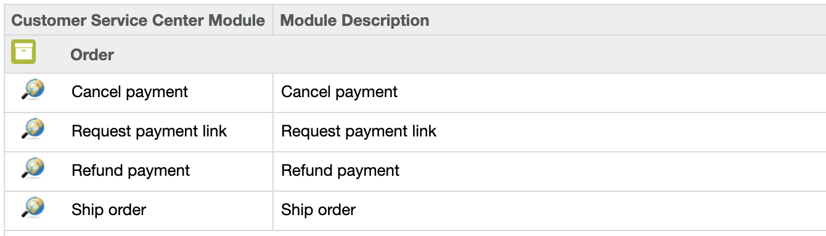

#### Performing a payment cancel

Order cancels are managed by custom actions on the order itself.

1. Press the **Find Order** button.
2. Select an order
3. Press the **More** button on the top right corner and select **Cancel payment**.
4. For orders created with the **payment API** you can cancel the whole payment.  
   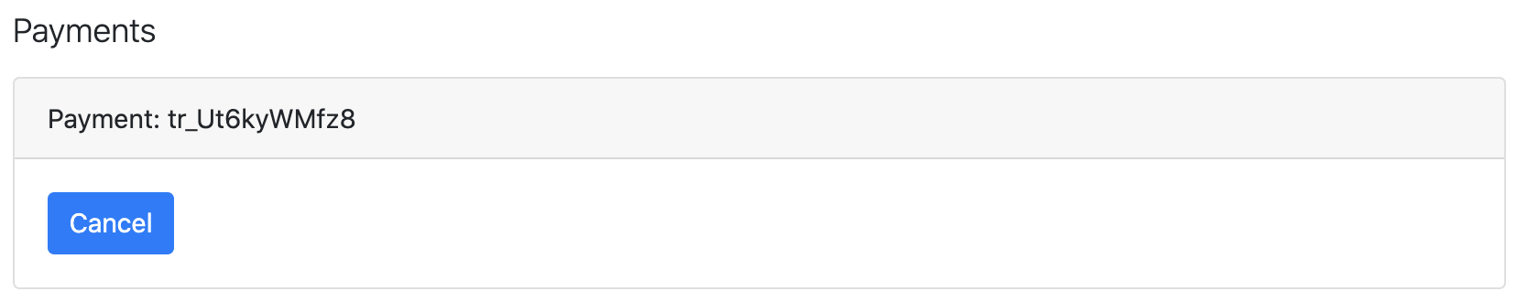
5. For orders created with the **order API** you can choose the products to cancel. (max amount already prefilled)   
   Some payment methods can be canceled by the merchant for a certain amount of time, usually until the next business day. Or as long as the Mollie payment status is open. Only orders that are CREATED/OPEN/NEW/COMPLETED can be canceled!  
   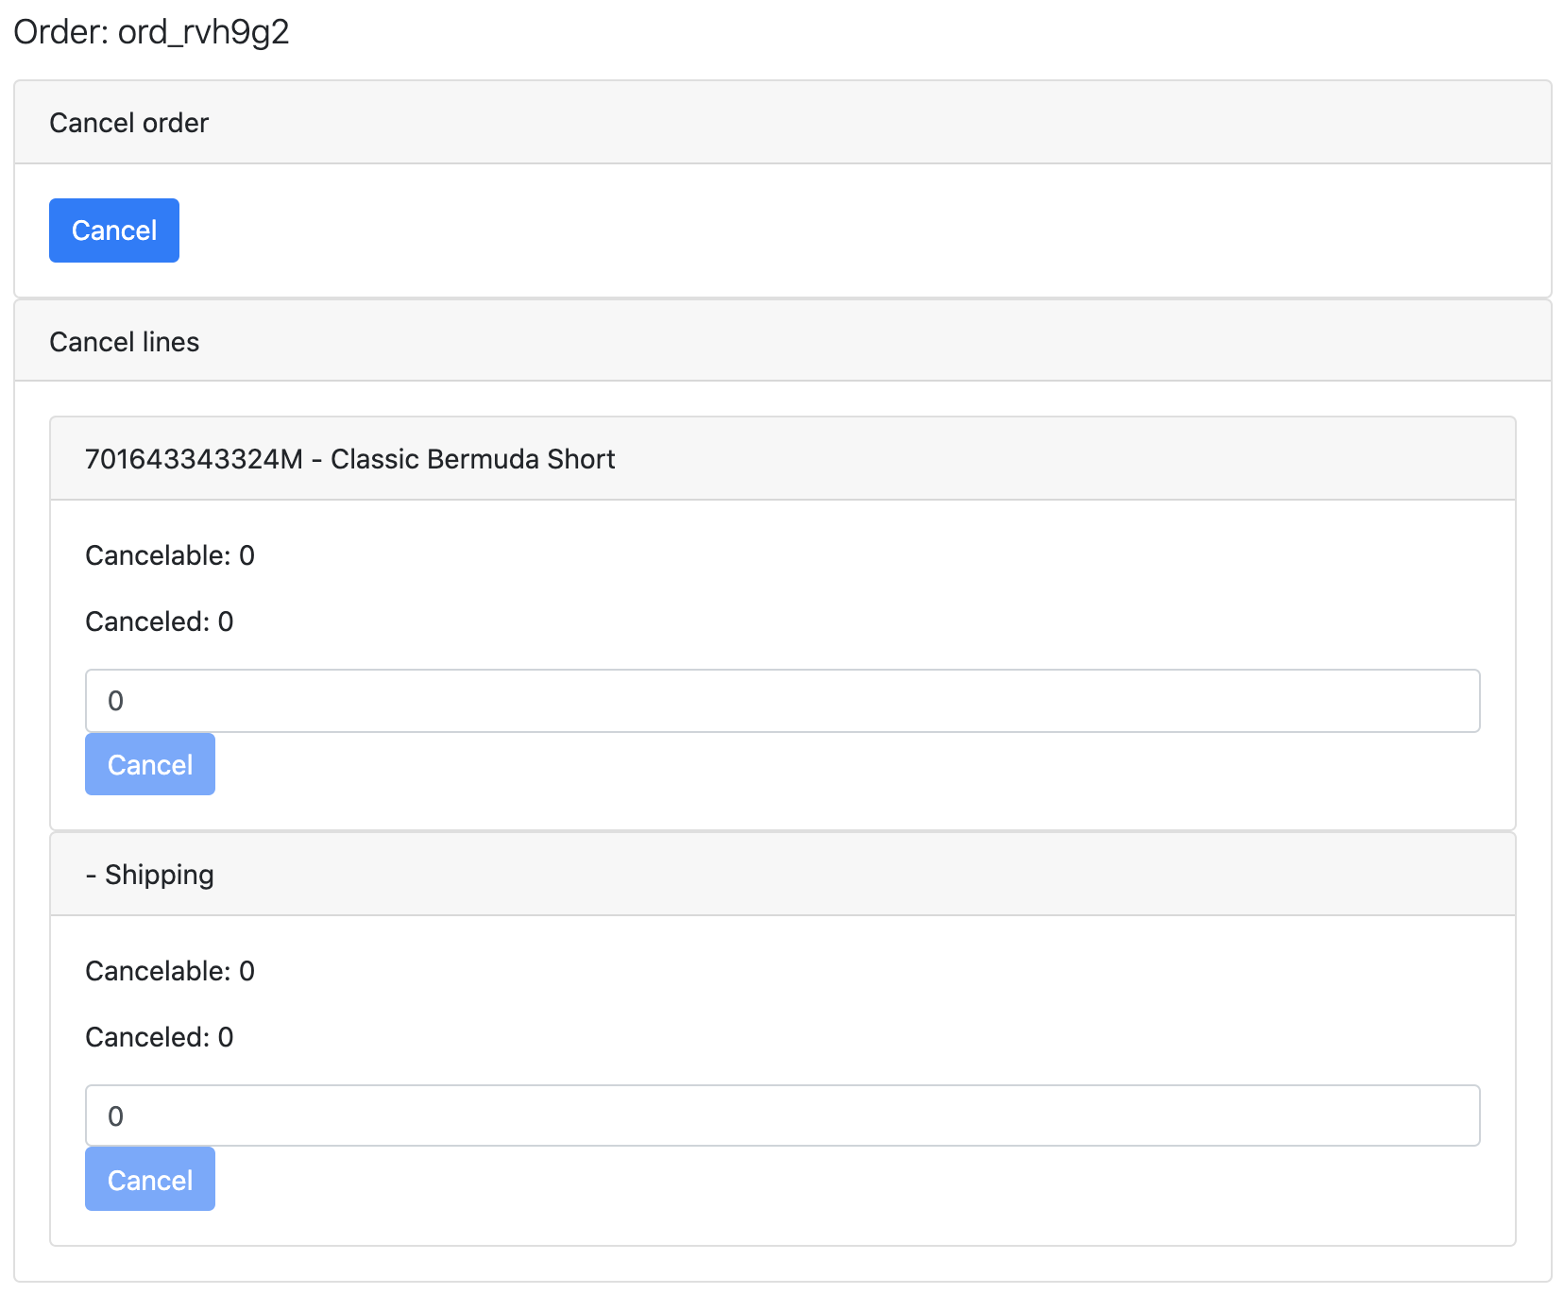
6. Click on **Cancel** to cancel the order or payment.

#### Performing a payment refund

Order refunds are managed by custom actions on the order itself.

1. Press the **Find Order** button.
2. Select an order
3. Press the **More** button on the top right corner and select **Refund payment**.
4. For orders created with the **payment API** you can choose the amount to refund. (max amount already prefilled)  
   Only orders that are OPEN/NEW/COMPLETED can be refunded!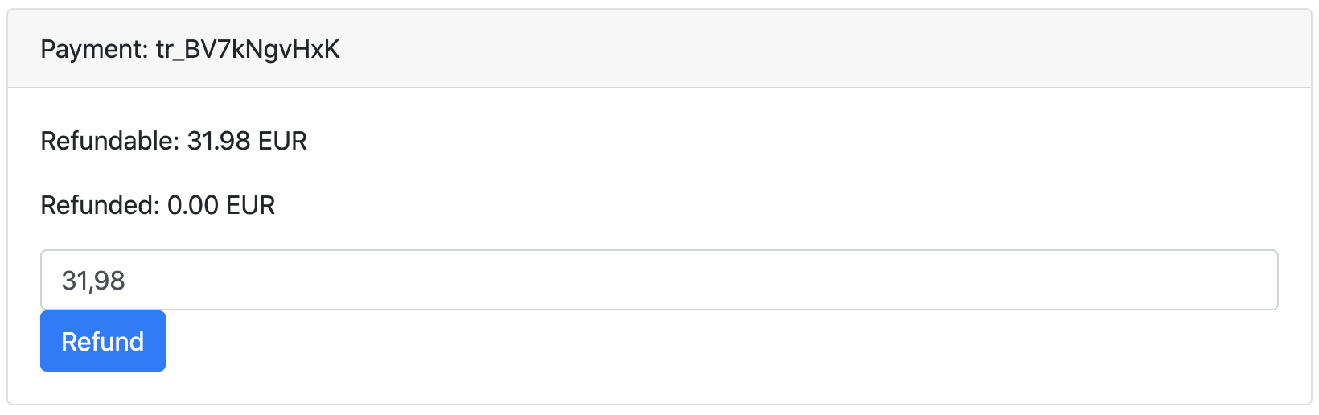
5. For orders created with the **order API** you can partially or fully refund the order. For each product the maximum quantity already prefilled.  
   Only orders that are OPEN/NEW/COMPLETED can be refunded!  
   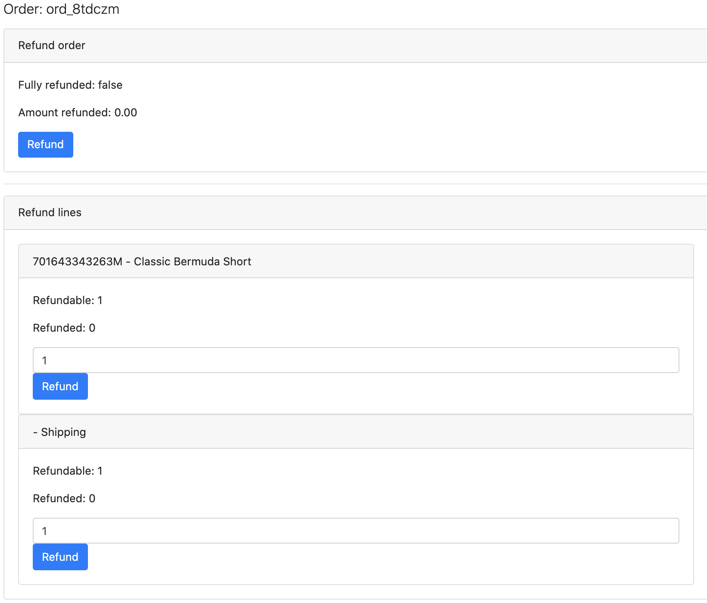
6. Click on **Refund** to refund the payment or order

#### Performing a order shipment

Order shipments are managed by custom actions on the order itself.

1. Press the **Find Order** button.
2. Select an order
3. Press the **More** button on the top right corner and select **Ship order**.
4. You can only ship orders that are created with the **order API**. You can partially or fully ship the order. For each product the maximum quantity is already prefilled   
   Only orders that are OPEN/NEW/COMPLETED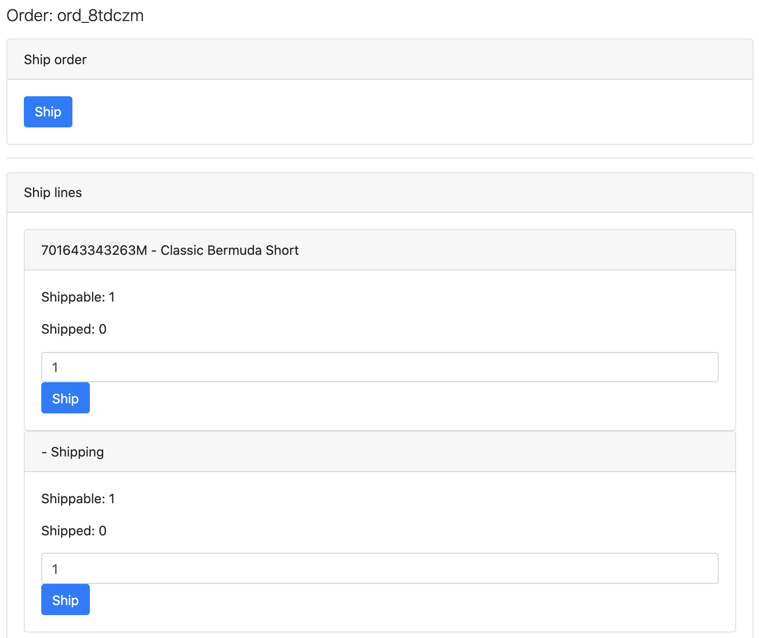
5. Click on **Ship** to ship the order or products.

#### Request payment link

Request payment link is managed by custom actions on the order itself.

1. Press the **Find Order** button.
2. Select an order
3. Press the **More** button on the top right corner and select **Request payment link**.   
   Only orders that are OPEN can be requested for a payment link.  
   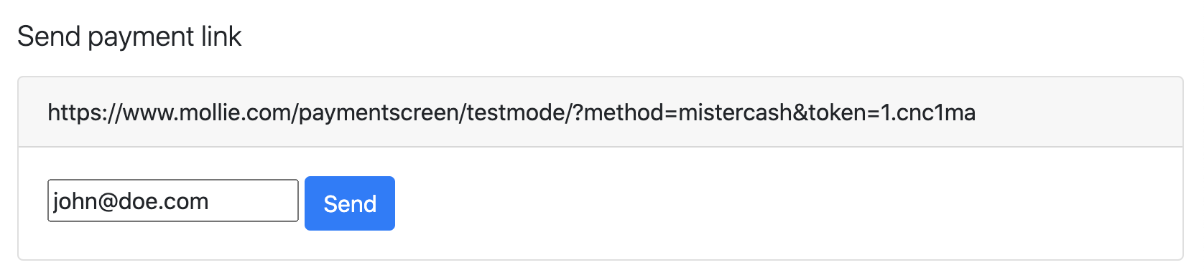
4. Click on **Send** to send the payment link to the customer.
   1. Please note that Salesforce does not provide mailing, the integrator needs to implement this by extending / overwrite the *bm_mollie/cartridge/scripts/payment/paymentLink* file

### Jobs

There is 1 job available that will handle status updates when Mollie can’t reach the SFCC webhook call to update the orders. Make sure to change the scope to the required sites.

There will be a Job available to check CREATED orders before a given time. The job will request the payment status from Mollie and update the SFCC order accordingly.

There are 2 parameters available:

* ExpireAfterHours
  + The job will collect orders with the CREATED status that are older than the specified number of hours
* IsDisabled
  + Enable to skip the step

# Known Issues

No known issues

# Release History

|  |  |  |
| --- | --- | --- |
| **Version** | **Date** | **Changes** |
| 20.1.0 | 2020-09-24 | Initial release |